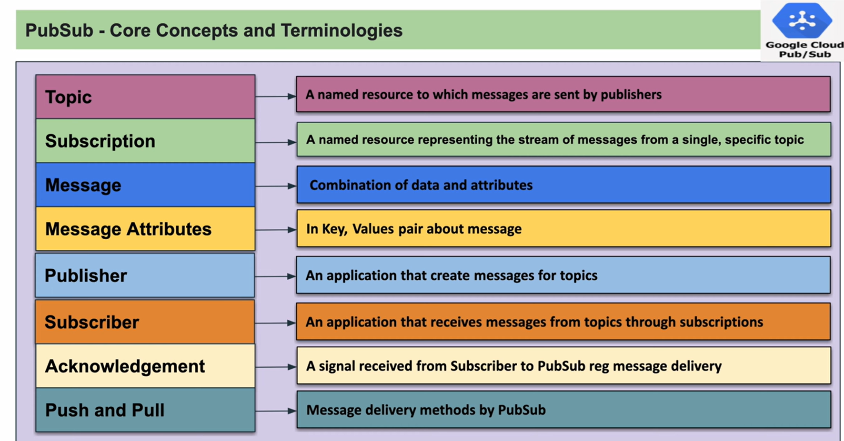

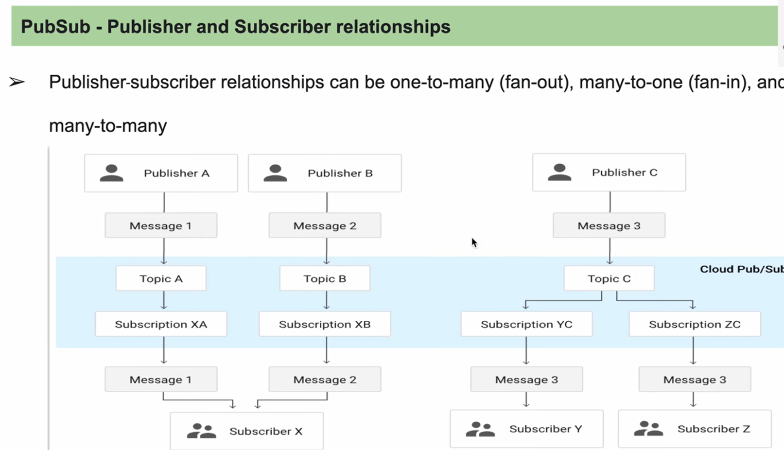

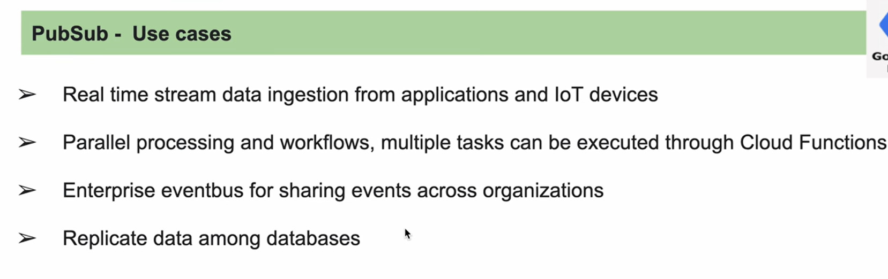

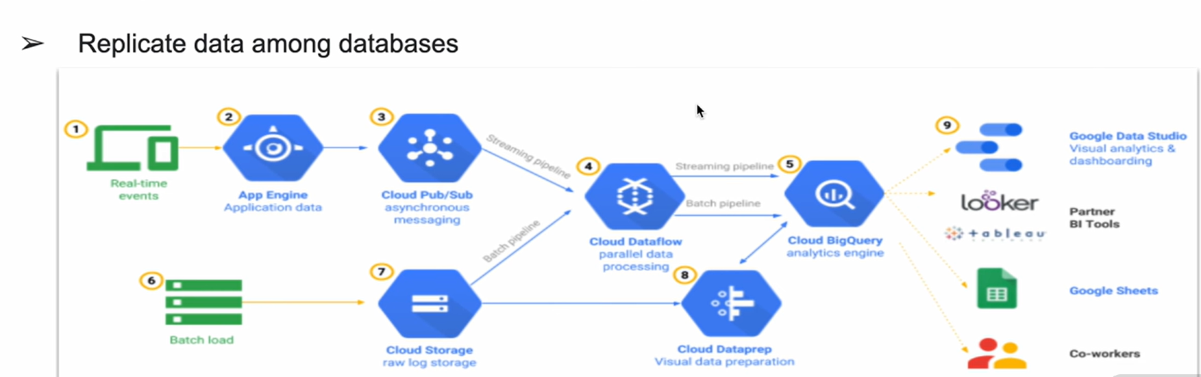
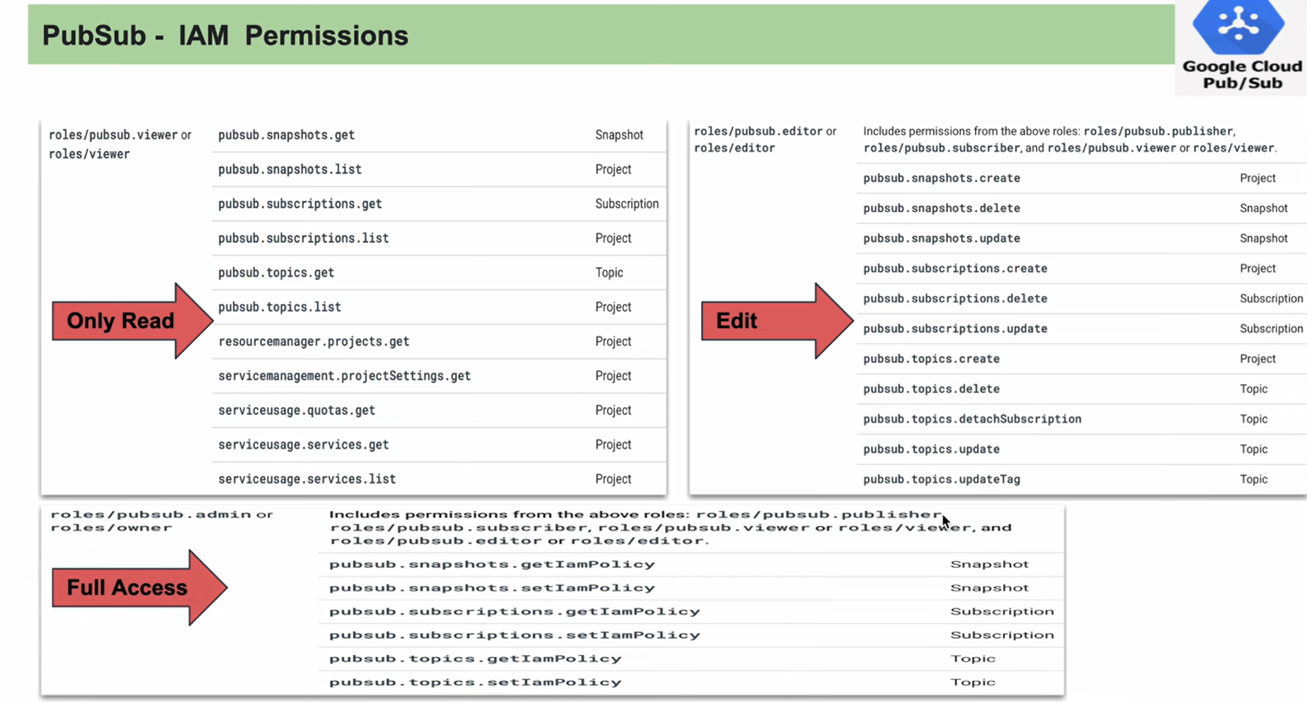

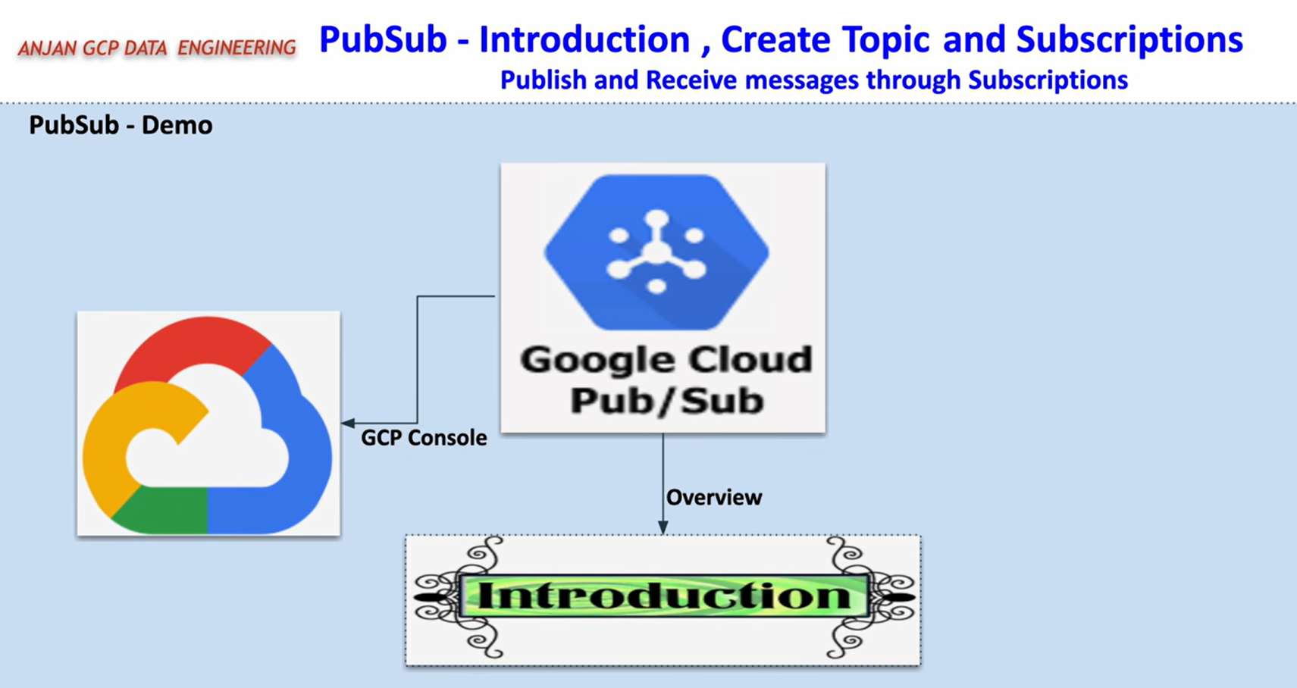

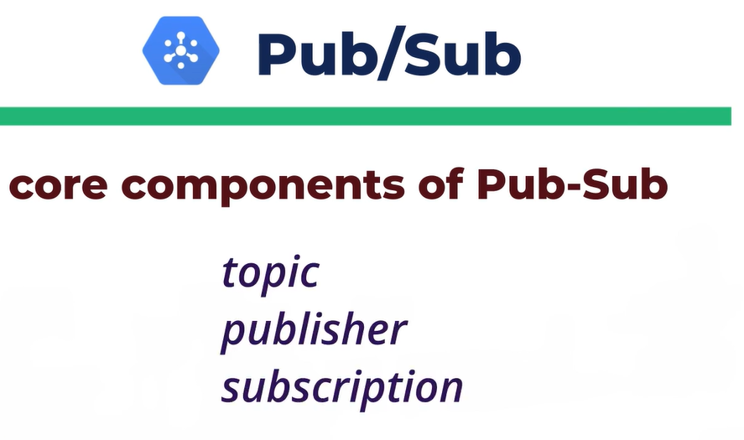
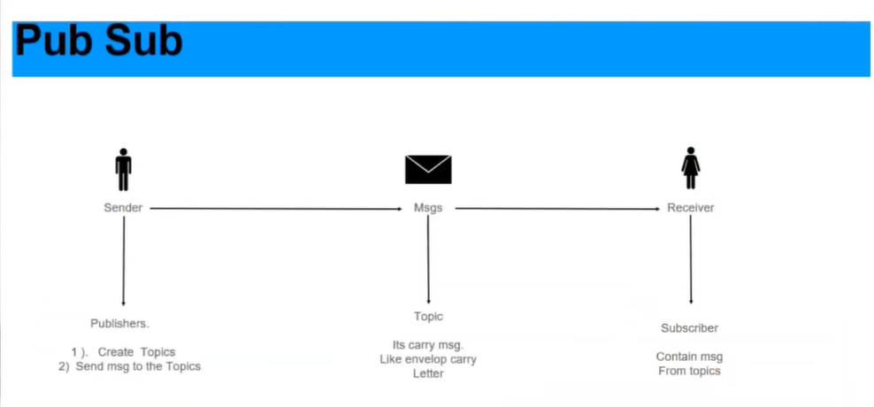
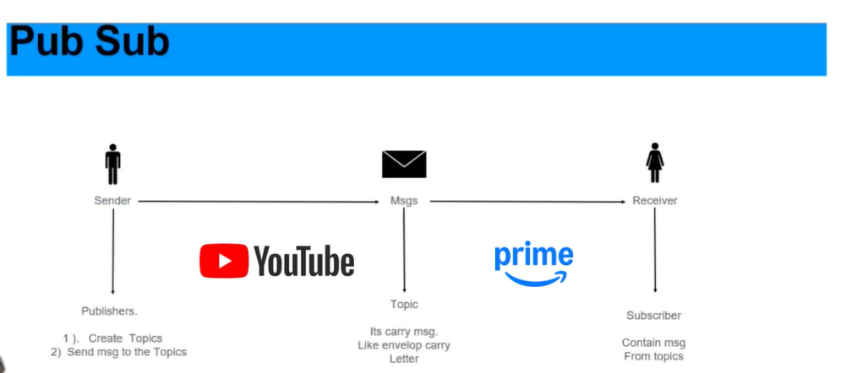

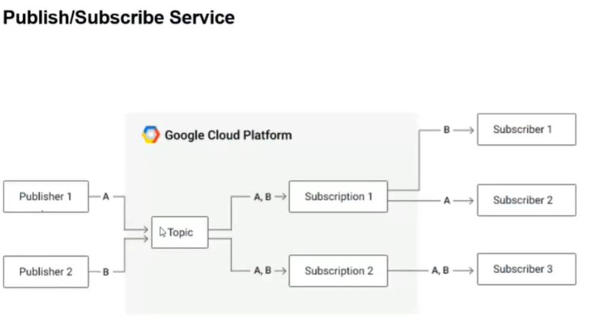

gcloud pubsub topics create my-demo-topic-from-gcloud

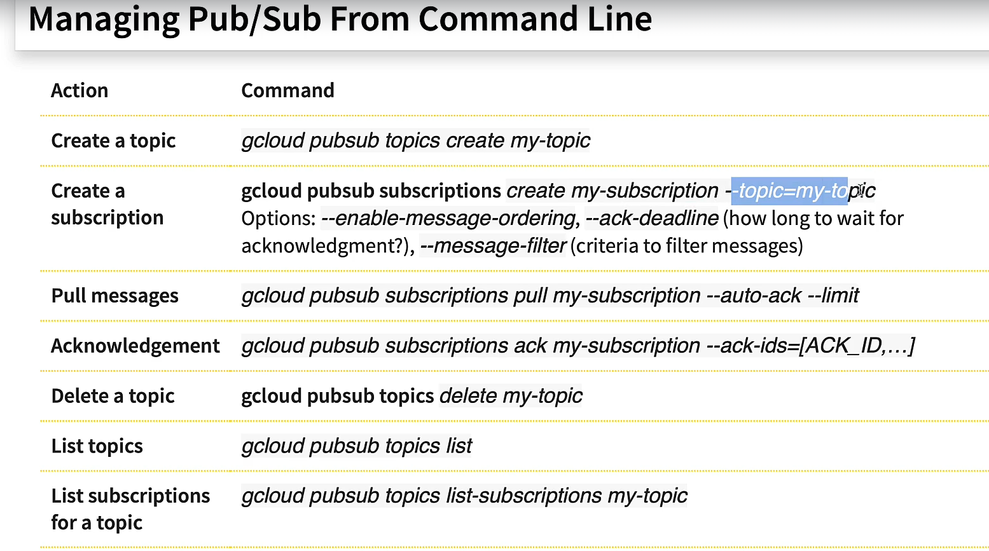

Welcome to Cloud Shell! Type "help" to get started.
Your Cloud Platform project in this session is set to bigquery-optimization-lab.
Use `gcloud config set project [PROJECT_ID]` to change to a different project.
geethasamynathan2011@cloudshell:~ (bigquery-optimization-lab)$ gcloud pubsub topics create my-demo-topic-from-gcloud
^C

Command killed by keyboard interrupt

geethasamynathan2011@cloudshell:~ (bigquery-optimization-lab)$ gcloud pubsub topics create my-demo-topic-from-gcloud
ERROR: Failed to create topic [projects/bigquery-optimization-lab/topics/my-demo-topic-from-gcloud]: Resource already exists in the project (resource=my-demo-topic-from-gcloud).
ERROR: (gcloud.pubsub.topics.create) Failed to create the following: [my-demo-topic-from-gcloud].
geethasamynathan2011@cloudshell:~ (bigquery-optimization-lab)$ gcloud pubsub topics create my-demo-topic
Created topic [projects/bigquery-optimization-lab/topics/my-demo-topic].
geethasamynathan2011@cloudshell:~ (bigquery-optimization-lab)$ gcloud pubsub subscriptions create my-demo-subscription --topic=my-demo-topic
Created subscription [projects/bigquery-optimization-lab/subscriptions/my-demo-subscription].
geethasamynathan2011@cloudshell:~ (bigquery-optimization-lab)$ gcloud pubsub subscriptions create my-demo-subscription1 --topic=my-demo-topic
Created subscription [projects/bigquery-optimization-lab/subscriptions/my-demo-subscription1].
geethasamynathan2011@cloudshell:~ (bigquery-optimization-lab)$ gcloud pubsub subscriptions pull my=demo-subscription
ERROR: (gcloud.pubsub.subscriptions.pull) INVALID_ARGUMENT: Invalid resource name given (name=projects/bigquery-optimization-lab/subscriptions/my=demo-subscription). Refer to https://cloud.google.com/pubsub/docs/pubsub-basics#resource_names for more information.
geethasamynathan2011@cloudshell:~ (bigquery-optimization-lab)$ gcloud pubsub subscriptions pull my-demo-subscription
gclous pubsub topicListed 0 items.
geethasamynathan2011@cloudshell:~ (bigquery-optimization-lab)$ gclous pubsub topics publish my-demo-topic --message="My First Message from Gcloud"
-bash: gclous: command not found
geethasamynathan2011@cloudshell:~ (bigquery-optimization-lab)$ gcloud pubsub topics publish my-demo-topic --message="My First Message from Gcloud"
messageIds:
- '20881234175085408'
geethasamynathan2011@cloudshell:~ (bigquery-optimization-lab)$ gcloud pubsub topics publish my-demo-topic --message="My Second Message from Gcloud"
messageIds:
- '20881234175096694'
geethasamynathan2011@cloudshell:~ (bigquery-optimization-lab)$ gcloud pubsub topics publish my-demo-topic --message="My third Message from Gcloud"
messageIds:
- '20885323149116135'
geethasamynathan2011@cloudshell:~ (bigquery-optimization-lab)$ gcloud pubsub subscriptions pull my-demo-subscription
DATA: My First Message from Gcloud
MESSAGE_ID: 20881234175085408
ORDERING_KEY:
ATTRIBUTES:
DELIVERY_ATTEMPT:
ACK_ID: RFAGFixdRkhRNxkIaFEOT14jPzUgKEUSBQgUBXx9cVhRdVhZGgdRDRlyfGgjOQgbAlMXUX9VWxENem1cbe31-_pEX0B3alIbAABGV39YXhsFbVhcfS_f4ujy8oyOf0AvOejhpZ1pe_Pc-PxuZiA9XxJLLD5-NjtFQV5AEkw9DkRJUytDCypYEU4EISE-MD5FUw
geethasamynathan2011@cloudshell:~ (bigquery-optimization-lab)$ gcloud pubsub subscriptions pull my-demo-subscription
DATA: My Second Message from Gcloud
MESSAGE_ID: 20881234175096694
ORDERING_KEY:
ATTRIBUTES:
DELIVERY_ATTEMPT:
ACK_ID: RFAGFixdRkhRNxkIaFEOT14jPzUgKEUSBQgUBXx9cFhRdV1ZfGhRDRlyfWB8PAlBCQERVi9cURsHaE5tdR-Sqe-RS0NUaFobCQNHUHpeXB4NYVpafAN5g_aD_e6YkU8JOjqG94i8bTuDh8FoZiM9XxJLLD5-NjtFQV5AEkw9DkRJUytDCypYEU4EISE-MD5FUw
geethasamynathan2011@cloudshell:~ (bigquery-optimization-lab)$ gcloud pubsub subscriptions pull my-demo-subscription
DATA: My First Message from Gcloud
MESSAGE_ID: 20881234175085408
ORDERING_KEY:
ATTRIBUTES:
DELIVERY_ATTEMPT:
ACK_ID: U0RQBhYsXUZIUTcZCGhRDk9eIz81IChFEgUIFAV8fXFYUXVYWRoHUQ0ZcnxoIzkIGwJTF1F_VVsRDXptXG3N9fv6RF9Ad2pSGwAARld_WF4bBW1YXH0v3-Lo8vKMjn9AKDnI4aWdaXvv4ugcZiA9XxJLLD5-NjtFQV5AEkw9DkRJUytDCypYEU4EISE-MD5F
geethasamynathan2011@cloudshell:~ (bigquery-optimization-lab)$ gcloud pubsub subscriptions pull my-demo-subscription
DATA: My Second Message from Gcloud
MESSAGE_ID: 20881234175096694
ORDERING_KEY:
ATTRIBUTES:
DELIVERY_ATTEMPT:
ACK_ID: UAYWLF1GSFE3GQhoUQ5PXiM_NSAoRRIFCBQFfH1wWFF1XVl8aFENGXJ9YHw8CUEJARFWL1xRGwdoTm11H-io75FLQ1RoWhsJA0dQel5cHg1hWlp8A3mD9oP97piRTwk9Ovz2iLxtO-_FqtBHZiM9XxJLLD5-NjtFQV5AEkw9DkRJUytDCypYEU4EISE-MD5FU0Q
geethasamynathan2011@cloudshell:~ (bigquery-optimization-lab)$ gcloud pubsub subscriptions pull my-demo-subscription
DATA: My First Message from Gcloud
MESSAGE_ID: 20881234175085408
ORDERING_KEY:
ATTRIBUTES:
DELIVERY_ATTEMPT:
ACK_ID: RFAGFixdRkhRNxkIaFEOT14jPzUgKEUSBQgUBXx9cVhRdVhZGgdRDRlyfGgjOQgbAlMXUX9VWxENem1cbaf0-_pEX0B3alIbAABGV39YXhsFbVhcfS_f4ujy8oyOf0AvOaLgpZ1pe5r2he5tZiA9XxJLLD5-NjtFQV5AEkw9DkRJUytDCypYEU4EISE-MD5FUw
geethasamynathan2011@cloudshell:~ (bigquery-optimization-lab)$ gcloud pubsub subscriptions pull my-demo-subscription --auto-ack
DATA: My Second Message from Gcloud
MESSAGE_ID: 20881234175096694
ORDERING_KEY:
ATTRIBUTES:
DELIVERY_ATTEMPT:
ACK_STATUS: SUCCESS
geethasamynathan2011@cloudshell:~ (bigquery-optimization-lab)$ gcloud pubsub subscriptions pull my-demo-subscription --auto-ack
DATA: My First Message from Gcloud
MESSAGE_ID: 20881234175085408
ORDERING_KEY:
ATTRIBUTES:
DELIVERY_ATTEMPT:
ACK_STATUS: SUCCESS
geethasamynathan2011@cloudshell:~ (bigquery-optimization-lab)$ gcloud pubsub subscriptions pull my-demo-subscription --auto-ack
DATA: My third Message from Gcloud
MESSAGE_ID: 20885323149116135
ORDERING_KEY:
ATTRIBUTES:
DELIVERY_ATTEMPT:
ACK_STATUS: SUCCESS
geethasamynathan2011@cloudshell:~ (bigquery-optimization-lab)$ gcloud pubsub subscriptions pull my-demo-subscription --auto-ack
Listed 0 items.
geethasamynathan2011@cloudshell:~ (bigquery-optimization-lab)$ gcloud pubsub subscriptions pull my-demo-subscription1
DATA: My Second Message from Gcloud
MESSAGE_ID: 20881234175096694
ORDERING_KEY:
ATTRIBUTES:
DELIVERY_ATTEMPT:
ACK_ID: UAYWLF1GSFE3GQhoUQ5PXiM_NSAoRRIFCBQFfH1wWFF1XVl8aFENGXJ9YHw8CUEJARFWL1xRGwdoTm11H4mo75FLQ1RoWhsJA0dQel5cHg1hWlp8A3nXkezg9KzHTwk9Op32iLxtO6SZ0rNHZiM9XxJLLD5-NjtFQV5AEkw9DkRJUytDCypYEU4EISE-MD5FU0Q
geethasamynathan2011@cloudshell:~ (bigquery-optimization-lab)$ gcloud pubsub subscriptions pull my-demo-subscription
Listed 0 items.
geethasamynathan2011@cloudshell:~ (bigquery-optimization-lab)$ gcloud pubsub subscriptions pull my-demo-subscription1
DATA: My Second Message from Gcloud
MESSAGE_ID: 20881234175096694
ORDERING_KEY:
ATTRIBUTES:
DELIVERY_ATTEMPT:
ACK_ID: RFAGFixdRkhRNxkIaFEOT14jPzUgKEUSBQgUBXx9cFhRdV1ZfGhRDRlyfWB8PAlBCQERVi9cURsHaE5tdR_yq--RS0NUaFobCQNHUHpeXB4NYVpafAN515Hs4PSsx08JOjrm9Yi8bTur8olbZiM9XxJLLD5-NjtFQV5AEkw9DkRJUytDCypYEU4EISE-MD5FUw
geethasamynathan2011@cloudshell:~ (bigquery-optimization-lab)$ gcloud pubsub subscriptions pull my-demo-subscription1
DATA: My First Message from Gcloud
MESSAGE_ID: 20881234175085408
ORDERING_KEY:
ATTRIBUTES:
DELIVERY_ATTEMPT:
ACK_ID: RFAGFixdRkhRNxkIaFEOT14jPzUgKEUSBQgUBXx9cVhRdVhZGgdRDRlyfGgjOQgbAlMXUX9VWxENem1cba73-_pEX0B3alIbAABGV39YXhsFbVhcfS-LhYfv6LjYf0AvOavjpZ1pe9fy0eZvZiA9XxJLLD5-NjtFQV5AEkw9DkRJUytDCypYEU4EISE-MD5FUw
geethasamynathan2011@cloudshell:~ (bigquery-optimization-lab)$ gcloud pubsub subscriptions pull my-demo-subscription1
DATA: My third Message from Gcloud
MESSAGE_ID: 20885323149116135
ORDERING_KEY:
ATTRIBUTES:
DELIVERY_ATTEMPT:
ACK_ID: U0RQBhYsXUZIUTcZCGhRDk9eIz81IChFEgUIFAV8fXFYUXVYWRoHUQ0ZcnxoIzkIGwJTF1F_VVoRDXptXG2p9_v6RF9Ad2pSGwQBR1B_W1IaDG5dX3Avi4WH7-i42H9AKDms46WdaXuw_pI3ZiA9XxJLLD5-NjtFQV5AEkw9DkRJUytDCypYEU4EISE-MD5F
geethasamynathan2011@cloudshell:~ (bigquery-optimization-lab)$ gcloud pubsub subscriptions pull my-demo-subscription
Listed 0 items.
geethasamynathan2011@cloudshell:~ (bigquery-optimization-lab)$ gcloud pubsub subscriptions pull my-demo-subscription1 --auto-ack
DATA: My First Message from Gcloud
MESSAGE_ID: 20881234175085408
ORDERING_KEY:
ATTRIBUTES:
DELIVERY_ATTEMPT:
ACK_STATUS: SUCCESS
geethasamynathan2011@cloudshell:~ (bigquery-optimization-lab)$ gcloud pubsub subscriptions pull my-demo-subscription1 --auto-ack
DATA: My Second Message from Gcloud
MESSAGE_ID: 20881234175096694
ORDERING_KEY:
ATTRIBUTES:
DELIVERY_ATTEMPT:
ACK_STATUS: SUCCESS
geethasamynathan2011@cloudshell:~ (bigquery-optimization-lab)$ gcloud pubsub subscriptions pull my-demo-subscription1 --auto-ack
DATA: My third Message from Gcloud
MESSAGE_ID: 20885323149116135
ORDERING_KEY:
ATTRIBUTES:
DELIVERY_ATTEMPT:
ACK_STATUS: SUCCESS
geethasamynathan2011@cloudshell:~ (bigquery-optimization-lab)$ gcloud pubsub topics list-subscriptions my-demo-toppic
ERROR: (gcloud.pubsub.topics.list-subscriptions) NOT_FOUND: Resource not found (resource=my-demo-toppic). This command is authenticated as geethasamynathan2011@gmail.com which is the active account specified by the [core/account] property.
geethasamynathan2011@cloudshell:~ (bigquery-optimization-lab)$ gcloud pubsub topics list-subscriptions my-demo-topic
---
projects/bigquery-optimization-lab/subscriptions/my-demo-subscription1
---
projects/bigquery-optimization-lab/subscriptions/my-demo-subscription
geethasamynathan2011@cloudshell:~ (bigquery-optimization-lab)$

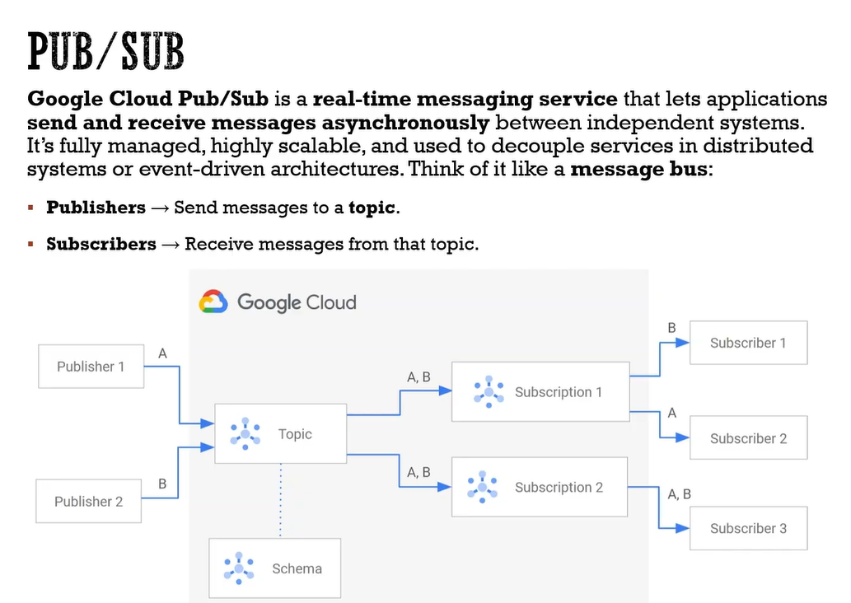

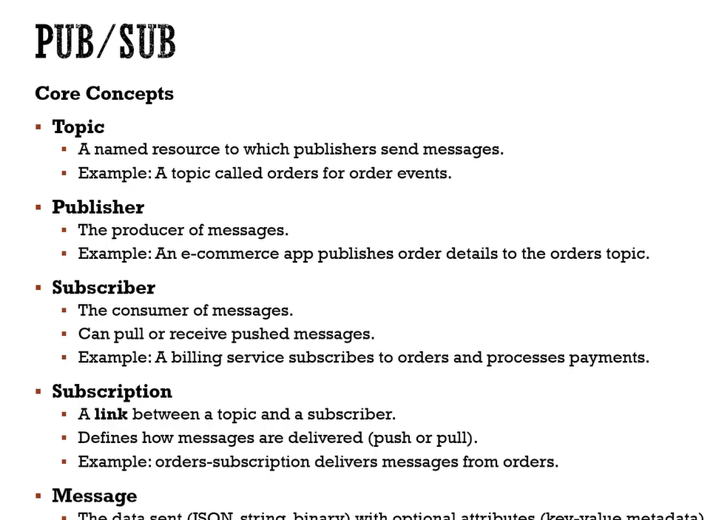

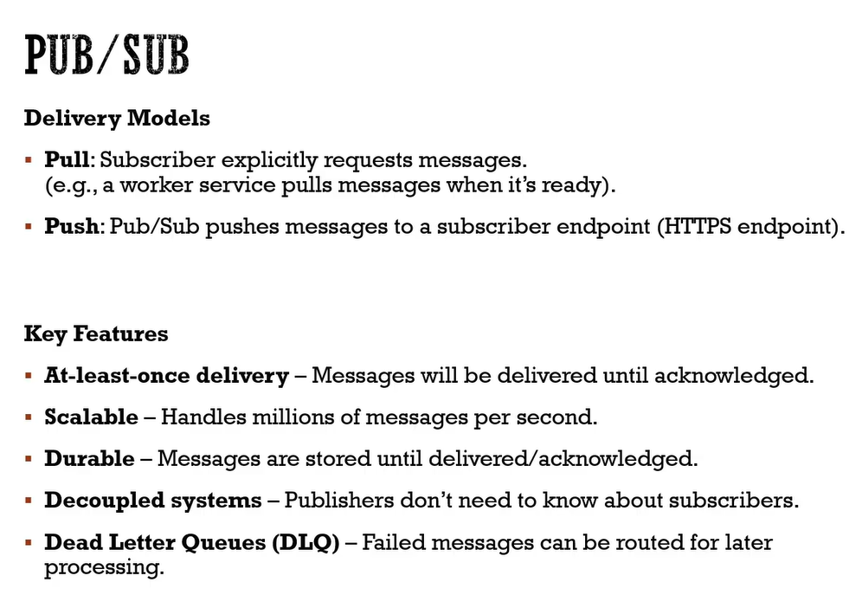

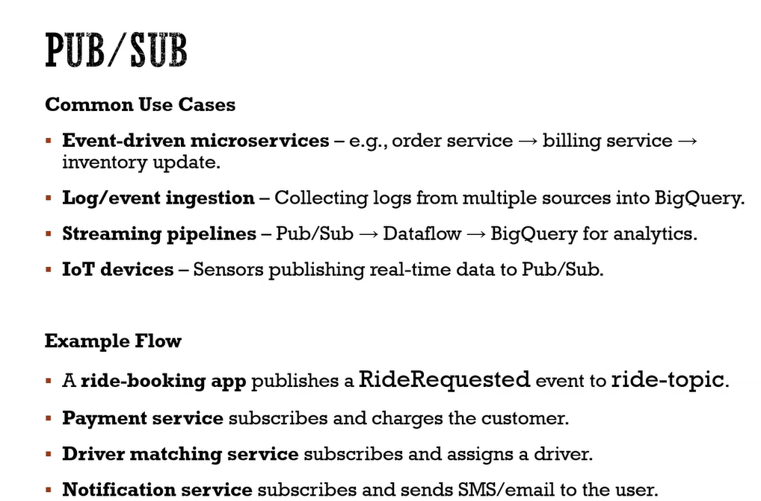

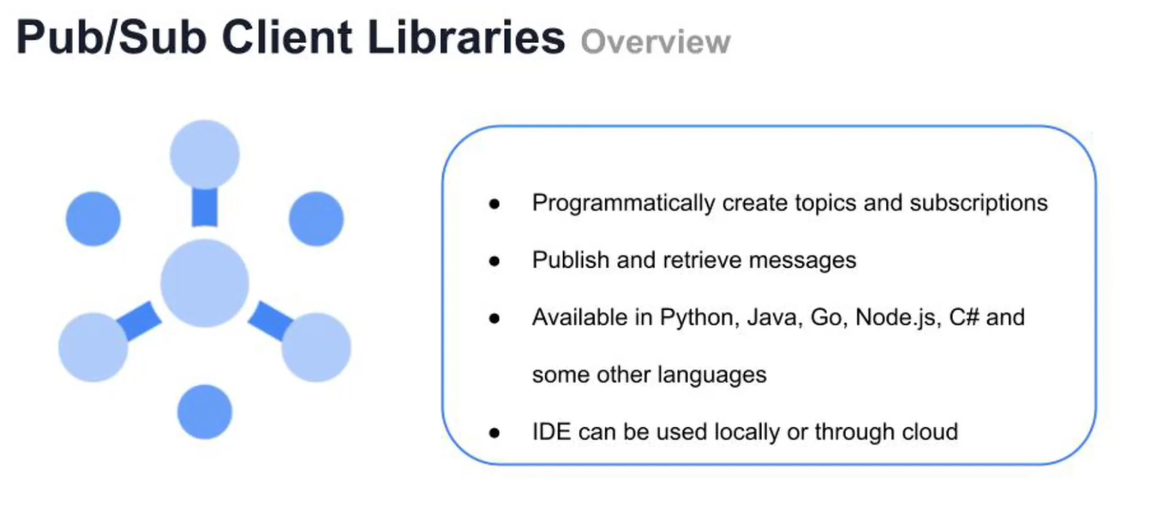
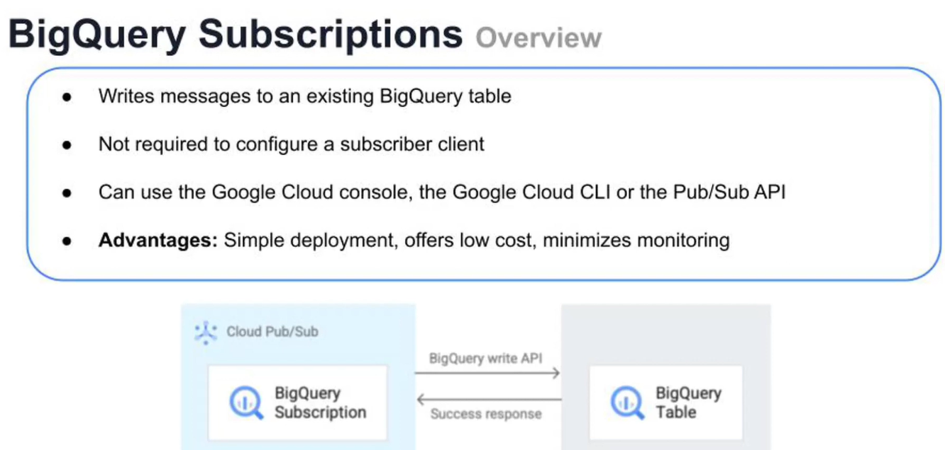

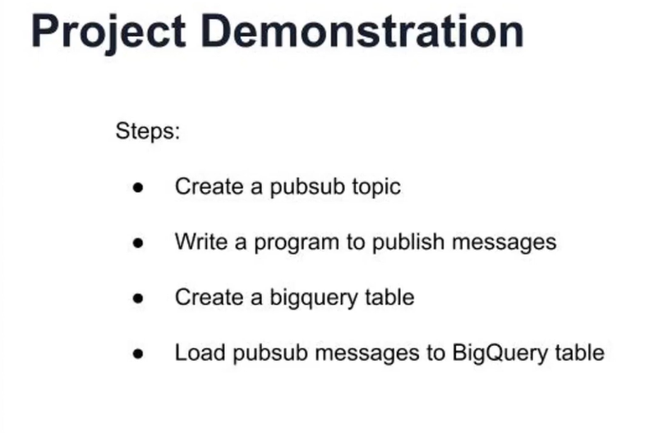

Enable pub/sub api
Bigquery api

Goto IAM
Under any service account. Add permissions. Roles. You need to provide role for that service account as Bigquery admin. Pub sub admin. Save that. After that you can download the Jason key to connect with this in your local machine

Next we will create a pub sub topic, name it as demo topic. For every topic default subscription will be added.

Open VS code to write a message to publish to this topic.

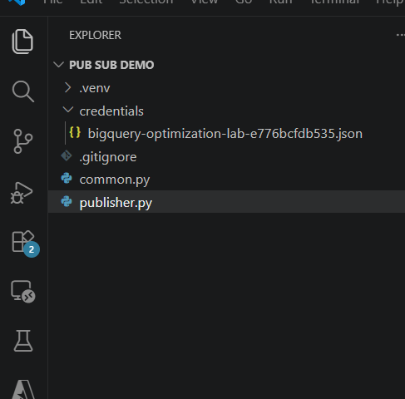
from pathlib import Path
import json
import os
import time

import requests
from google.cloud import pubsub_v1

PROJECT_ID = "bigquery-optimization-lab"
TOPIC_ID = "demo-topic"

# Find the credentials folder relative to publisher.py.
SCRIPT_DIRECTORY = Path(__file__).resolve().parent

CREDENTIALS_PATH = (
SCRIPT_DIRECTORY
/ "credentials"
/ "bigquery-optimization-lab-e776bcfdb535.json"
)

# Stop with a clear message when the file is missing.
if not CREDENTIALS_PATH.is_file():
raise FileNotFoundError(
"Service-account JSON file was not found.\n"
f"Expected location: {CREDENTIALS_PATH}\n"
"Copy the JSON file into the credentials folder or correct the filename."
)

os.environ["GOOGLE_APPLICATION_CREDENTIALS"] = str(CREDENTIALS_PATH)

publisher = pubsub_v1.PublisherClient()

# Build the official topic resource path.
topic_path = publisher.topic_path(PROJECT_ID, TOPIC_ID)

API_URL = "https://official-joke-api.appspot.com/random_joke"

def get_activity() -> dict:
"""Retrieve one activity from the external API."""

response = requests.get(
API_URL,
timeout=15,
)

response.raise_for_status()
return response.json()

def publish_activity(activity: dict) -> None:
"""Publish one JSON message and wait for confirmation."""

message_data = json.dumps(activity).encode("utf-8")

publish_future = publisher.publish(
topic_path,
data=message_data,
source="bored-api",
message_type="activity",
)

# Waiting for result exposes authentication, topic and IAM errors.
message_id = publish_future.result(timeout=30)

print(f"Published message ID: {message_id}")
print(f"Activity: {activity}")

def main() -> None:
print(f"Credentials: {CREDENTIALS_PATH}")
print(f"Topic: {topic_path}")
print("Publisher started. Press Ctrl+C to stop.")

try:
while True:
try:
activity = get_activity()
publish_activity(activity)
except requests.RequestException as error:
print(f"External API error: {error}")
except Exception as error:
print(f"Publishing error: {type(error).__name__}: {error}")

time.sleep(20)

except KeyboardInterrupt:
print("\nPublisher stopped.")

if __name__ == "__main__":
main()

Run python publisher.py
Credentials: C:\Personal\RevatureUSACTS\Notes\training_notes\week-8-notes\Demos\pub sub demo\credentials\bigquery-optimization-lab-e776bcfdb535.json
Topic: projects/bigquery-optimization-lab/topics/demo-topic
Publisher started. Press Ctrl+C to stop.
Published message ID: 20885254137217304
Activity: {'type': 'general', 'setup': 'What time did the man go to the dentist?', 'punchline': 'Tooth hurt-y.', 'id': 260}
Published message ID: 20615816588814205
Activity: {'type': 'general', 'setup': 'What do you get hanging from Apple trees?', 'punchline': 'Sore arms.', 'id': 228}
Published message ID: 20889187752181421
Activity: {'type': 'programming', 'setup': 'To understand what recursion is...', 'punchline': 'You must first understand what recursion is', 'id': 27}
Published message ID: 20804369237843731
Activity: {'type': 'general', 'setup': 'What is the hardest part about sky diving?', 'punchline': 'The ground.', 'id': 245}
Published message ID: 20172158086512285
Activity: {'type': 'general', 'setup': 'Why did the kid cross the playground?', 'punchline': 'To get to the other slide.', 'id': 327}
Published message ID: 20804468436765838
Activity: {'type': 'general', 'setup': 'Hey, dad, did you get a haircut?', 'punchline': 'No, I got them all cut.', 'id': 76}
Published message ID: 20886556400540997
Activity: {'type': 'general', 'setup': 'What musical instrument is found in the bathroom?', 'punchline': 'A tuba toothpaste.', 'id': 259}
Published message ID: 20804351851280971
Activity: {'type': 'general', 'setup': 'What do I look like?', 'punchline': 'A JOKE MACHINE!?', 'id': 188}

Goto Google cloud console -> Topics -> subscriptions
Messages Pull

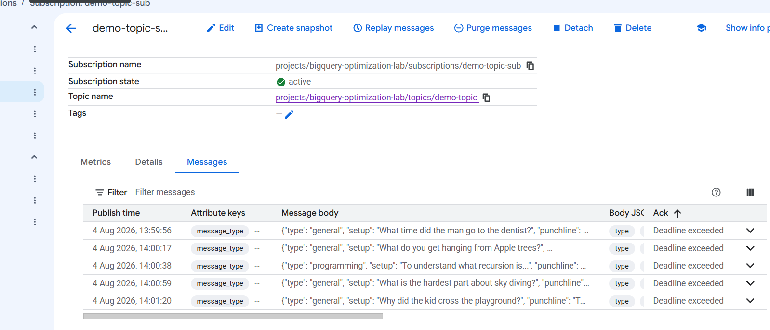

Goto bigquery => Create dataset -> Region asia-south mumbai

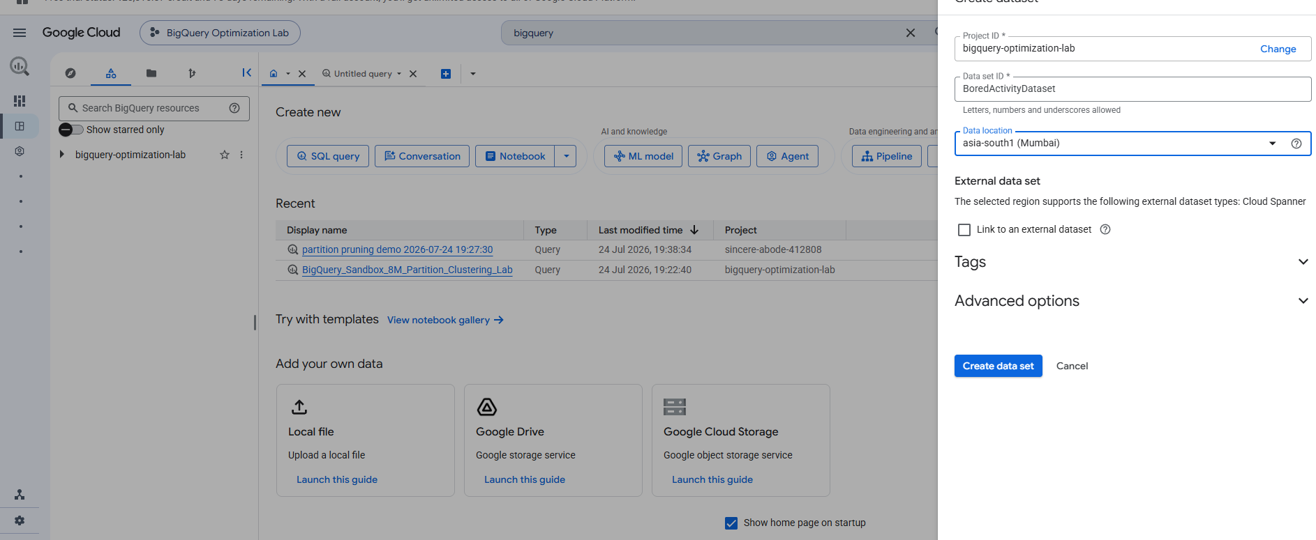
Create table
Source empty table
Schema
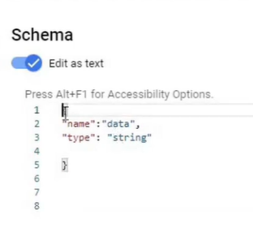

Goto pubsub
- Create subscription
- Joke-sub
- Delivery type => write to BigQuery
Service Account
After creating service account
Goto table refresh and check the message are received

